Filmabende der Frauen in Schwarz (Wien) im
Österreichisch-Arabischen Begegnungszentrum
Kegelgasse 25 / Ecke Blattgasse, 1030 Wien
Mittwoch, 25. April 2018, 19.00 Uhr

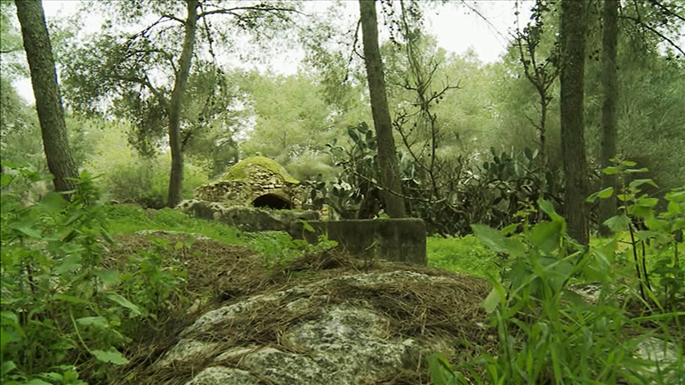
The Village Under The Forest
in English Language (67 min)

Winner of the Audience Award at Encounters South African International Documentary Festival in 2013

Film shown during International Conference of Women in Black in Cape Town. Introduction of film and highlights from conference by Mary Pampalk.

This film explores the hidden remains of the destroyed Palestinian village of Lubya, which lies under a purposefully cultivated forest plantation called South Africa Forest. Using the forest and the village ruins as metaphors, the documentary explores themes related to the erasure and persistence of memory and dares to imagine a future in which dignity, acknowledgement and co-habitation become shared possibilities in Israel/Palestine.
Directed by Emmy-winner Mark J Kaplan and written and narrated by scholar and author Heidi Grunebaum, The Village Under The Forest unfolds as a personal meditation from the Jewish Diaspora.

SYNOPSIS As a child in South Africa co-director Grunebaum put her pennies in a box to help build a forest in Israel. Twenty years later she revisits the forest she helped finance, only to find that it was not a project for growth but rather one that would disguise deliberate obliteration. Under a cultivated plantation called ‘South Africa Forest’ are hidden the remains of the destroyed Palestinian village of Lubya. Prompted by a questioning of what it meant to be complicit with Apartheid, the film tackles the question of responsibility in light of the erasure of the village.

INHALTSANGABE: Diese Dokumentation blickt auf das zerstörte palästinensische Dorf Lubya zurück. Das Gebiet ist eines von vielen, das von Israel bewusst von einer Waldfläche (hier dem „South Africa Forest“) überdeckt wurde, was Regisseur Mark Kaplan und Autorin Heidi Grunebaum auch in einem metaphorischen Sinne begreifen, um das Erlöschen ebenso wie die Beständigkeit von Erinnerungen zu untersuchen. Darauf aufbauend wünschen sie sich eine Zukunft, in der eine friedliche Co-Existenz von Israelis und Palästinensern möglich ist.

Entrance free – donations are gladly accepted / Eintritt frei – wir freuen uns über eine Spende.

